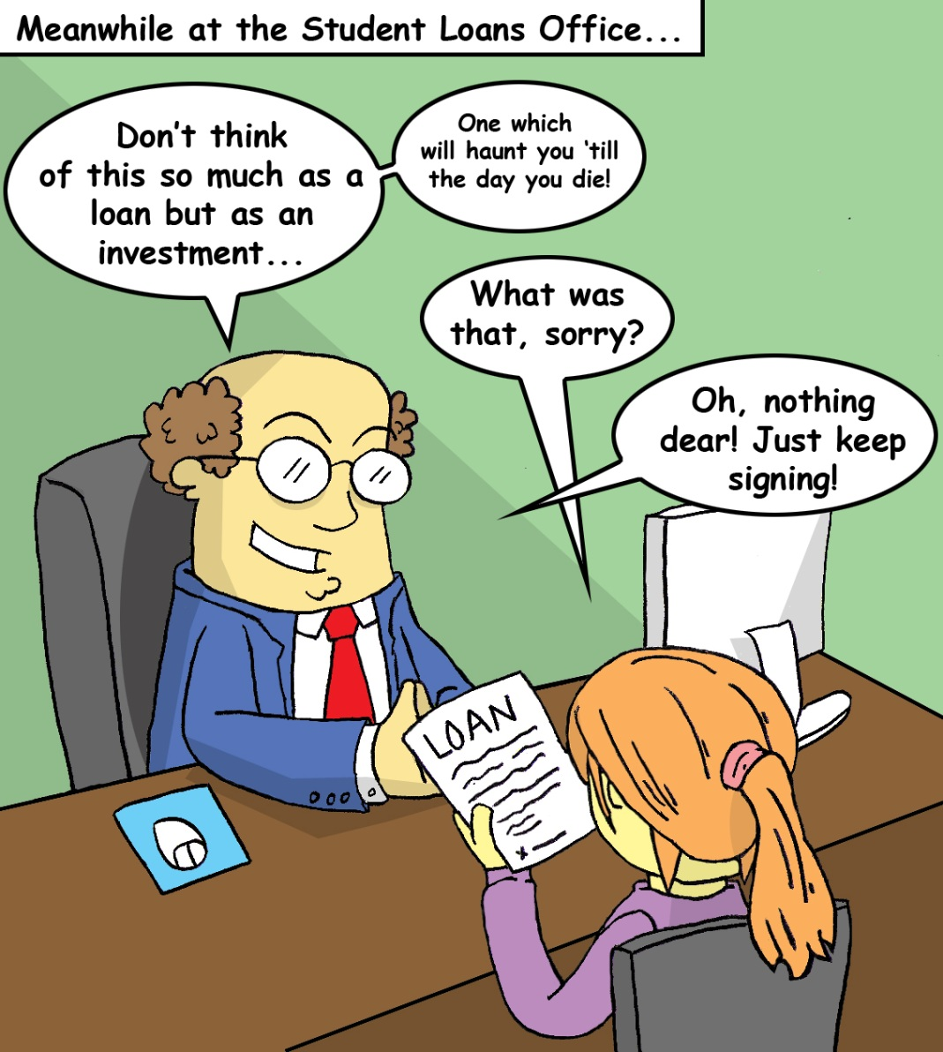

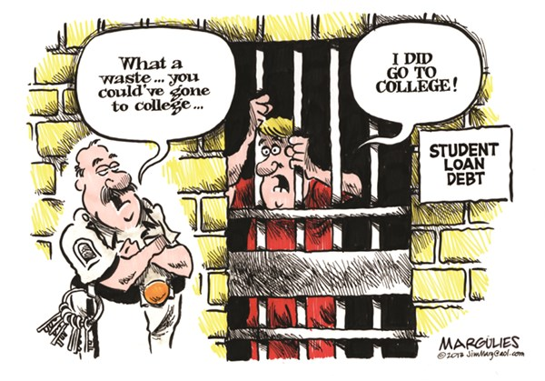

**Task 1:** Describe the cartoons!

**Task 2:** Do you thing the cartoons are exaggerated? Explain why!